MATLAB SIMULATION OF SUPERHETERODYNE RECEIVER FOR AM COMMUNICATION SYSTEM WITH FREQUENCY MIXING AND FILTERING
Analog and Digital Communication — MATLAB Experiment
Date of Experiment | 07/10/2026
Performed By | Lokesh A
Register Number | 192512293
1. Aim
To simulate a superheterodyne receiver for an AM communication system in MATLAB and observe frequency mixing, intermediate-frequency (IF) filtering, envelope detection and recovery of the original message signal.
2. MATLAB Program
clc;
clear;
close all;
% Parameters
fs = 100000;
t = 0:1/fs:0.02;
fm = 500; % Message frequency
fc = 10000; % Carrier frequency
fLO = 14550; % Local oscillator frequency
% IF = fLO - fc = 4550 Hz
% Message Signal
m = cos(2*pi*fm*t);
% Carrier Signal
c = cos(2*pi*fc*t);
% AM Signal
am = (1 + m).*cos(2*pi*fc*t);
% Local Oscillator
LO = cos(2*pi*fLO*t);
% Frequency Mixing
mixed = am .* LO;
% IF Filter
[b,a] = butter(4,5000/(fs/2));
IF = filter(b,a,mixed);
% Envelope Detection
env = abs(hilbert(IF));
% Display Results
figure;
subplot(5,1,1)
plot(t,m)
title('Message Signal')
xlabel('Time (s)')
ylabel('Amplitude')
grid on
subplot(5,1,2)
plot(t,c)
title('Carrier Signal')
xlabel('Time (s)')
ylabel('Amplitude')
grid on
subplot(5,1,3)
plot(t,am)
title('AM Signal')
xlabel('Time (s)')
ylabel('Amplitude')
grid on
subplot(5,1,4)
plot(t,IF)
title('Intermediate Frequency (IF) Signal')
xlabel('Time (s)')
ylabel('Amplitude')
grid on
subplot(5,1,5)
plot(t,env)
title('Recovered Signal')
xlabel('Time (s)')
ylabel('Amplitude')
grid on
3. Output
The MATLAB simulation produces the following waveforms for the message, carrier, AM signal, intermediate-frequency signal and recovered signal.
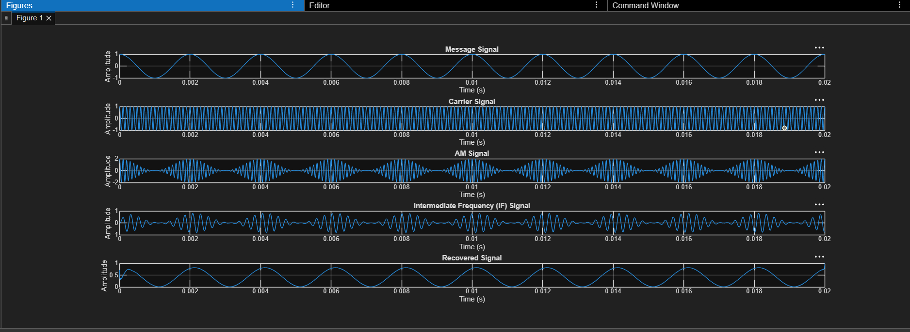
Figure 1. MATLAB output showing the message, carrier, AM, IF and recovered signals.
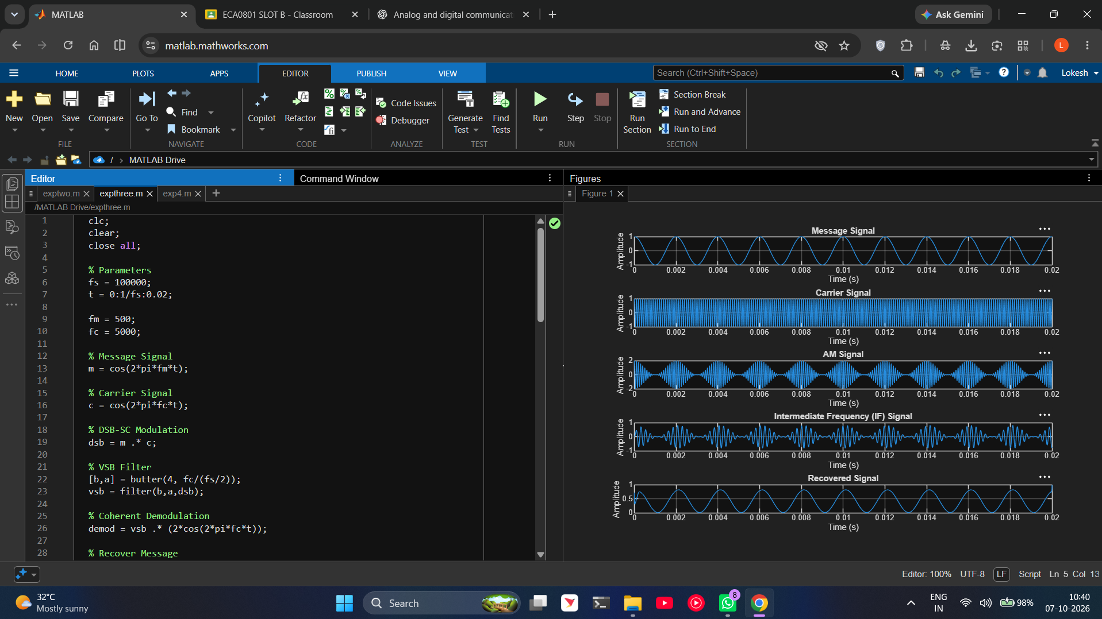
Figure 2. MATLAB editor and graphical simulation output.
4. Applications
- AM radio receivers used for broadcast reception.
- Communication receivers that translate a selected radio-frequency signal to a fixed intermediate frequency for filtering and amplification.
- Receiver-system demonstrations and laboratory studies of frequency conversion, IF filtering and envelope detection.
5. Alignment with Analog and Digital Communication
This experiment demonstrates AM signal generation, local-oscillator mixing, intermediate-frequency selection, filtering and envelope detection. These stages illustrate the operation of a superheterodyne receiver and connect the AM modulation concepts to practical receiver architecture.
ADC Concept | MATLAB Implementation | Observed Output
Message generation | 500 Hz cosine signal | Message Signal plot
AM modulation | Message modulates a 10 kHz carrier | AM Signal plot
Local oscillator | 15.55 kHz local oscillator signal | Mixing stage in code
Frequency mixing | AM signal multiplied by local oscillator | Produces sum and difference frequency components
IF filtering | Butterworth filter with 5 kHz cutoff | Intermediate Frequency (IF) plot
Envelope detection | Hilbert-transform envelope | Recovered Signal plot
6. Justification
- The message, carrier and AM signal plots show the input and modulated signal stages before frequency conversion.
- The local oscillator and mixer illustrate how a received RF signal can be shifted to an intermediate frequency.
- The IF filter represents frequency selection, allowing the receiver to process the desired converted signal.
- Envelope detection illustrates recovery of the message information from the AM waveform.
- The experiment links the theory of AM communication with the main functional blocks of a superheterodyne receiver.
7. Conclusion
The superheterodyne receiver for an AM communication system was modelled in MATLAB. The simulation generated the message, carrier and AM signals, performed frequency mixing, applied IF filtering and displayed the detected envelope. The experiment demonstrates the basic stages of frequency conversion and signal recovery in an AM receiver.
Performed by
Lokesh A (192512293)

